* Stress and strength
* Uncertainty
* Stochastic and deterministic methods
  + Deterministic method
 $n_{d}=\frac{S}{σ}$

 $F.S.=\frac{S}{σ}$  - after you find stress rounded up
* **Design factor and factor of safety**
* Reliability method of design
* Definitions of
  + Reliability R
 $R=1-p_{f}$

 $R=\prod{}R_{i}$

+ Probability of failure $P_{f}$
  + Margin of safety m
 $m=S-σ$

 ${\bar{n}}_{d}=\frac{μ_{S}}{μ_{σ}}=\frac{\bar{S}}{\bar{σ}}$

+ Probability density function PDF
  + Normal Gaussian distribution
 $z=\frac{x-μ_{x}}{{\hat{σ}}_{x}}$

   - * Turns a distribution into one with a 0 mean and standard deviation
    - $μ$ is mean
 $μ_{add}=μ_{1}+μ_{2}$

 $\hat{σ}$  - is standard deviation
 ${\hat{σ}}_{add}=\sqrt{{{\hat{σ}}_{1}}^{2}+{{\hat{σ}}_{2}}^{2}}$

 + Cumulative distribution function $Φ$
    - CDF table like Table A-10
 $Φ(Z_{a})=a, Z_{a}<0$ $Φ(Z_{a})=1-a, Z_{a}>0$

 $a$ - is value from the table
    - 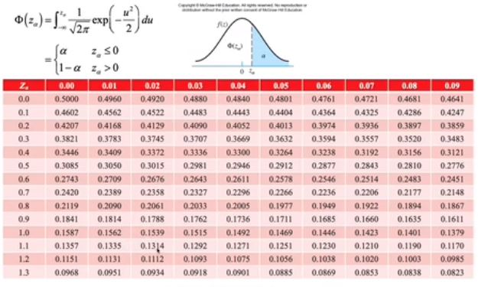
  + **Relation between design factor and reliability**
${\bar{n}}_{d}=(1±\sqrt{1-(1-z^{2}{C_{s}}^{2})(1-z^{2}{c_{σ}}^{2})})/(1-z^{2}{c_{s}}^{2})$

$C_{s}=\frac{{\hat{σ}}_{s}}{μ_{s}}$ $C_{σ}=\frac{{\hat{σ}}_{σ}}{μ_{σ}}$

$z= -\frac{{\bar{n}}_{d}-1}{\sqrt{{\bar{n}}_{d}{C_{2}}^{2}+{C_{σ}}^{2}}}$

* Dimensional tolerance terms
* Simplest dimensioning
* Tolerance stack up
* Chapter 2
  + Relationship between true stress and true strain
  + How to compare materials in terms of their properties
    - Resilience
      * Area under elastic portion of curve
 $u_{R}=\frac{1}{2}S_{y}ϵ_{y}=\frac{S^{2}}{2E}$

   - Toughness
      * Total area under stress strain curve
 $u_{T}=\frac{1}{2}(S_{y}+S_{u})ϵ_{f}$

 + Strain-strengthening equation
 $σ_{T}=σ_{o}{ϵ_{T}}^{m}$

 + Hardness
    - Steel:
      * $S_{u}=0.5 H_{B}$ in Ksi
      * $S_{u}=3.4 H_{B}$ in MPa
    - Cast Iron
      * $S_{u}=0.23{ H}_{B}-12.5$ in Ksi
      * $S_{u}=1.58 H_{B}-8.6$ in MPa
  + Ashby charts to choose a material based on guidelines